**BASHSCRIPTING TASK – 03**

NAME : Pallavi Nimmala

Do : 10/13/2023

**1.Create on Bash script to check if a directory is available or not.**

Purpose - creation of directory and checking directory existence in a single terminal using if-script

***i. creation of directory in bash scripting***

d="execute"

# Check if the directory already exists

if [ ! -d "$d" ]

then

# If it doesn't exist, create it

mkdir "$d"

echo "Directory '$d' created."

else

# If it already exists, display a message

echo "Directory '$d' already exists."

fi

***ii. checking for directory Existence***

if [ -d "execute" ]

then

echo "Directory 'execute' is already existed"

else

echo "Directory 'execute' is not existed"

fi

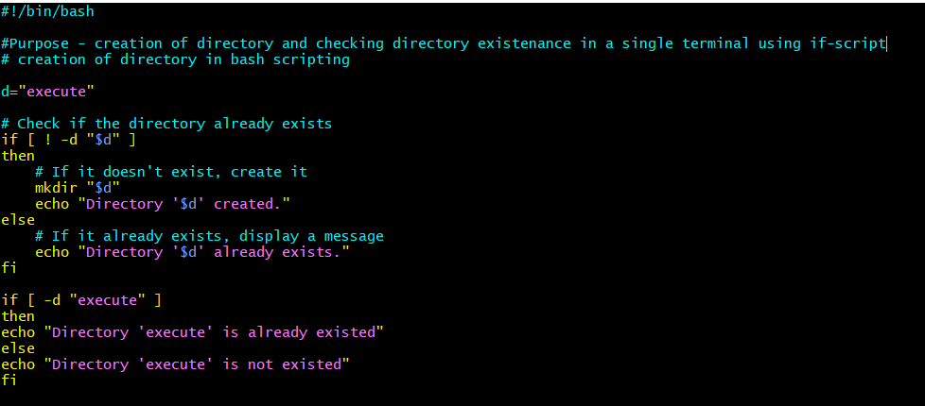

***2) Create a bash script which will create multiple files.***

#purpose - creating multiple files

#

for f in {1..5}

do

touch "$f"

echo file "$f" is created

done

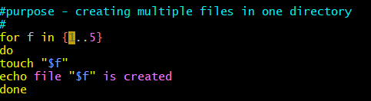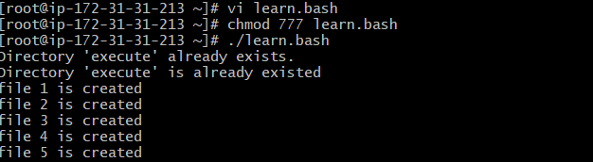

3) Create a bash script to take backup of a directory.

4) Create a bash script to install nginx in ec2 server.

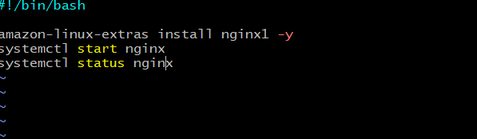

5) Create a bash script to install Apache Tomcat in ec2 server.

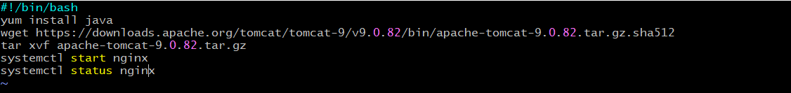

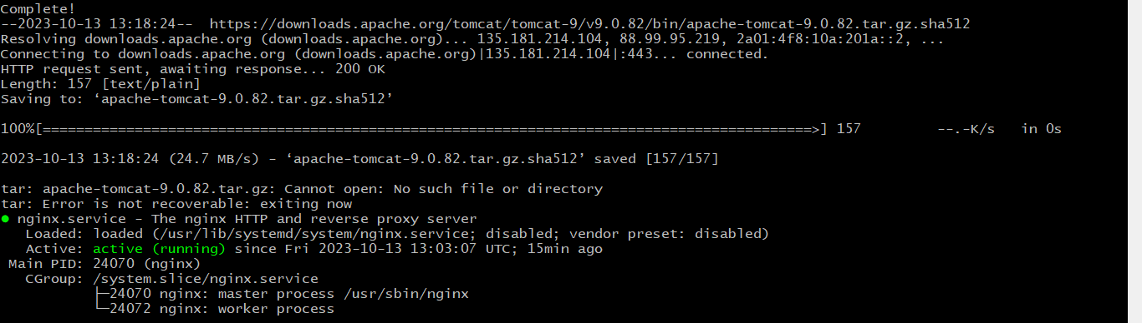

6) Create a bash script to check list if nginx service is running or not,if not running

then script should start the service.

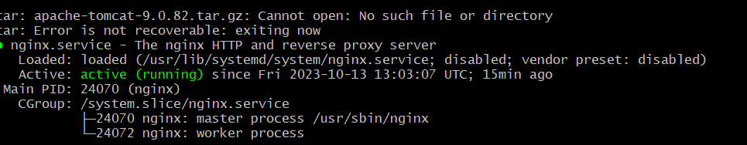

7) Create a bash script for calculator.

8) Create a bash script to check if directory is avaialble or not,if not then create a directory.



9) Create bash script to delete last 3 lines for a file.

[root@ip-172-31-31-213 ~]# vi abc.txt

[root@ip-172-31-31-213 ~]# cat abc.txt

1

2

3

4

5

6

7

8

9

10

To delete the lines temporarily

[root@ip-172-31-31-213 ~]# sed -e :a -e '$d;N;2,3ba' -e 'P;D' abc.txt

1

2

3

4

5

6

7

To delete the files permanently

[root@ip-172-31-31-213 ~]# cat abc.txt

1

2

3

4

5

6

7

8

9

10

